Year 1 and 2 Knowledge Organiser – Term 1 – What is London like?
Key Vocabulary | Key Knowledge
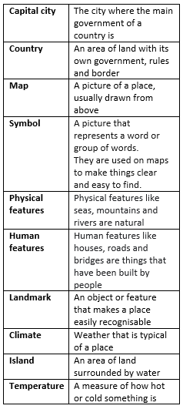 | 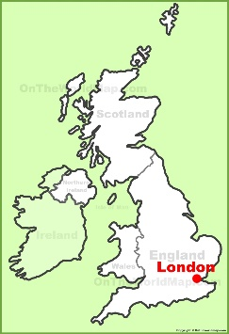  - There are four countries in the United Kingdom (UK):  • England  • Scotland  • Wales  • Northern Ireland  - It is an island surrounded by seas  - London is the capital city of England and the United Kingdom.  - London is in the South of England and is the largest city in England.  - The River Thames flows through London.  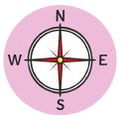  - There are lots of different ways of travelling around London. There are train stations, the London Underground (sometimes called the ‘tube’) and buses.  - London has lots of famous landmarks. These include the London Eye, Big Ben, the Houses of Parliament, Tower Bridge and Westminster Abbey.  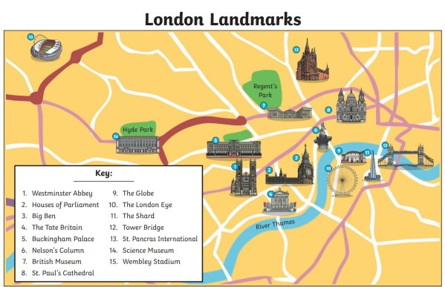  - While there are lots of buildings, London also has lots of green spaces in its parks, including Hyde Park and Regents Park.  - The King lives in Buckingham Palace in London.  - London has a temperate climate. This means that temperatures vary all year round but are generally not extremely hot or extremely cold. Weather is seasonal and summers are often warm and winters are often cool.

Year 1 and 2 Knowledge Organiser – Term 2 – What was London like in the past?
Key Vocabulary | Key Knowledge
 | 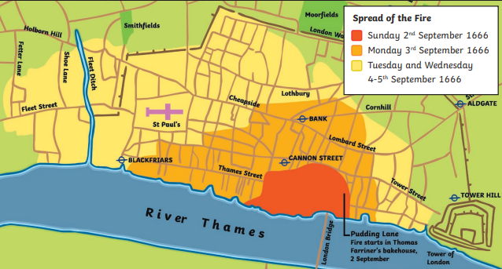  The Great Fire of London  - The fire started on Sunday 2nd September 1666 in Thomas Farriner’s bakery on Pudding Lane.  - It hadn’t rained for months so the buildings were very dry.  - In 1666, the buildings in London were made of wood and straw and they were very close together, making it easy for the flames to spread.  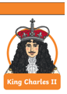  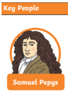  - Strong winds were blowing, which helped the flames to spread.  - People used leather buckets and water squirts to try to put the fire out, but these did not work.  - Later in the week, King Charles II ordered buildings to be pulled down to make fire breaks to stop the flames from spreading.  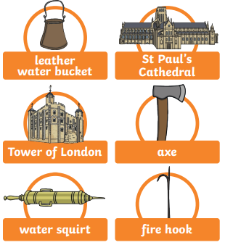  - By Thursday 6th September, the wind had died down. This meant that people were able to put out the flames.  - Thousands of houses were destroyed so many people were homeless.  - King Charles II ordered that buildings should be rebuilt from brick or stone and that streets should be made wider. This was to stop another fire from spreading like the Great Fire of London did.  - One of the ways we know about the fire is because people wrote about it in their diaries. Samuel Pepys wrote a diary about it.
  17th Century | From the year 1601 to 1700
  Bakery | A place where bread and cakes are made and sold
  Embers | Small pieces of glowing coal or wood in a dying fire
  Diary | A book that people write about their lives in
  Eye-witness | A person who has seen something and can give a description of it
  Flammable | When something burns easily
  Fire hooks | Giant hooks used to pull down houses
  Fire break | When buildings are destroyed to make a gap so that fire cannot spread
  Monarch | A person who rules over a place, usually a king or queen

