Year 3 and 4 Knowledge Organiser – Term 1 - Why are rivers important?
Key Vocabulary | Key Knowledge
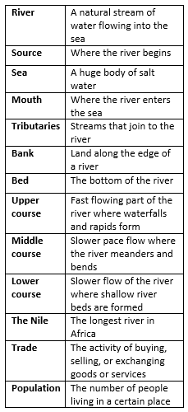 | 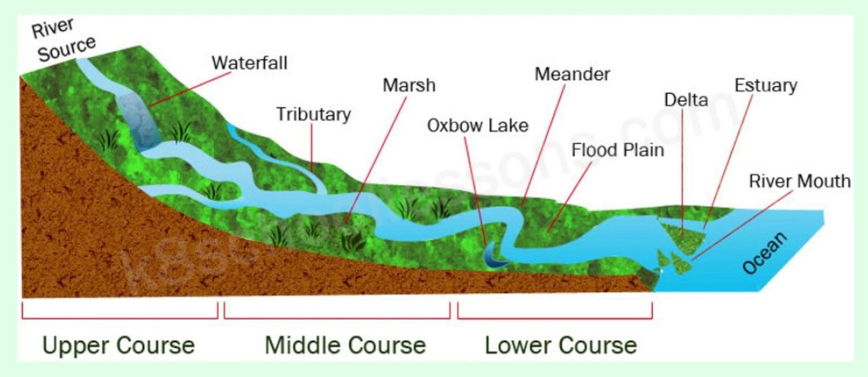  - A river is a path that flows downhill towards the ocean.  - The start of the river is called the source.  - The end of the river is called the mouth.  - Rivers and streams will join together before they reach the mouth, these are called tributaries.  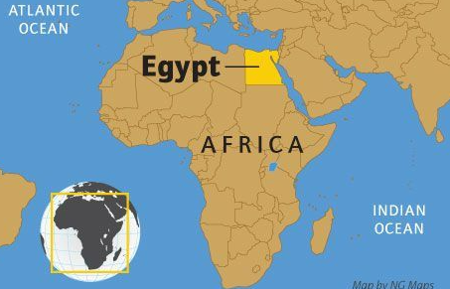  Egypt and The Nile  - Egypt is in the continent of Africa.  - The Nile river runs through 10 countries and is 6,695km long.  - The Nile empties into the Mediterranean Sea on Egypt’s north coast.  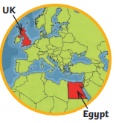  - The soil on the banks of the Nile is very fertile and is used for farming.  - More than 95% of Egypt’s population depend on the Nile and live within a few miles of the river banks  - Canals were built to connect to the Nile and it is used as a trade route between Africa and European countries.  - The Nile is used as a source of hydroelectric power.  - The main agricultural trade products of Egypt are fruits and vegetables, cotton, rice, corn and wheat, as well as crude oil and petroleum products.

Year 3 and 4 Knowledge Organiser – Term 2 – Why are rivers important?
Key Vocabulary | Key Knowledge
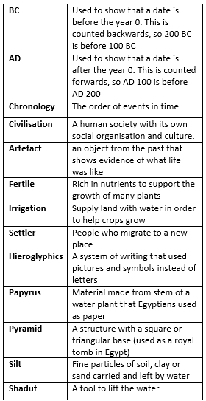 | 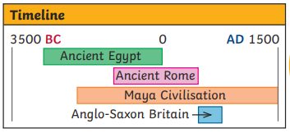  - The first people to live on the banks of the Nile were hunters and fishermen.  - By 3000BC a civilisation was established.  - The river Nile was essential to life in ancient Egypt. Every year, it flooded, leaving behind a black silt that enriched the soil making it very fertile for growing crops.  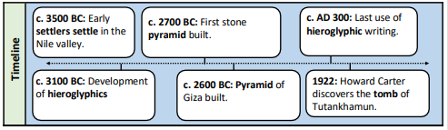  - Ancient Egyptians settled near the banks of the Nile as it was considered a prime location and they were among the first civilisations to use irrigation systems.  - The Nile also provided mud for bricks and pots, opportunities for fishing, papyrus reeds and a key means of transport.  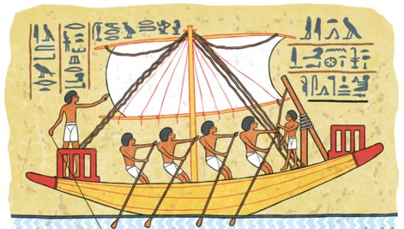  - Ancient Egyptians were the first civilisation to write. They used ink and paper called Papyrus.  - We know about ancient Egyptian life because of evidence such as the pyramids, the artefacts that were found there and methods of communications such as the use of hieroglyphics and papyrus rolls.  - There was no money in ancient Egypt so people traded by swapping things like pottery, food and jewellery.  - Boats were used to travel up and down the Nile to trade throughout the country. At first, they were made of papyrus then the Egyptians began to make them from wood.

