Year 5 and 6 Knowledge Organiser – Term 1 – Why are rainforests important?
Key Vocabulary | Key Knowledge
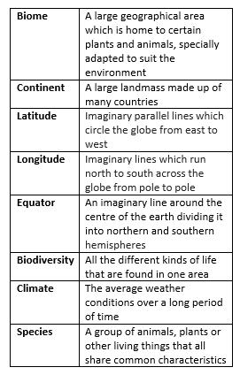 | 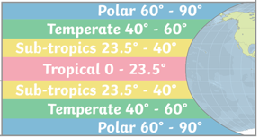  - The Americas are two separate continents consisting of North America and South America.  - North America contains 23 countries and South America contains 12 countries.  - There are 4 main climate zones across the world, determined by latitude.  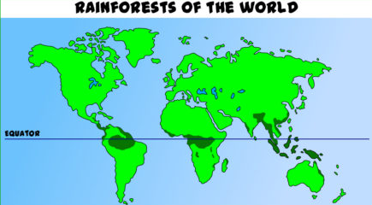  - The world is also split into different biomes – aquatic, desert, forest, grassland, rainforest and tundra.  - There are two types of rainforests, tropical and temperate. Tropical rainforests are found closer to the equator where it is warm. Temperate rainforests are found near the cooler coastal areas further north or south of the equator.  - Healthy rainforest biomes are rich in biodiversity.  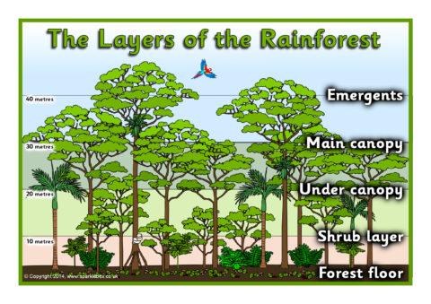  - The Amazon Rainforest is found in South America, and it goes across many countries such as Brazil, Peru, Ecuador, Venezuela, and Colombia.  - It is 5.5 million square km and is the largest tropical rainforest in the world.  - 1/10 of all known plant and animal species on the planet live in the Amazon rainforest.  - The Amazon rainforest is changing over time due to deforestation and climate change.

Year 5 and 6 Knowledge Organiser – Term 2 – How important are rainforests?
Key Vocabulary | Key Knowledge
 | 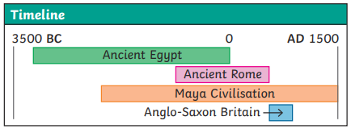  - The ancient Maya were a civilisation that lived between 2000BC and 1500AD.  - They were an extremely successful civilisation and were highly advanced in writing, art and science for their time.  - They lived in Mesoamerica (now Southern Mexico and Central America).  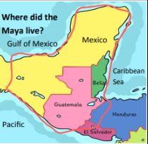  - Mesoamerica was made up of mountains, coasts and rainforests.  - Forests were burned and the nutrients from the ash made the soil very fertile.  - Maize was a very important crop that formed up to 80% of the Maya people’s diets. They believed that the first humans were made from maize dough by the gods.  - Other crops included squash, avocados, beans, cacao and cotton.  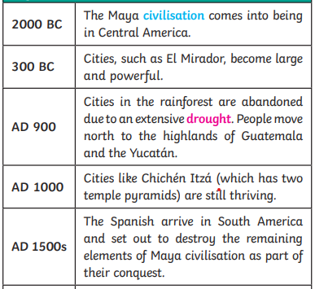  - The Maya believed in and worshipped a number of different gods, who had a good side and a bad side. The Maya would dance, sing and sometimes make offerings of blood to the gods.  - Priests were very important in Maya society as it was believed that they could communicate directly with the gods. They would perform different rituals during festivals or special ceremonies in order to appeal to the gods.  - Most of what we know about the Maya comes from what remains of their architecture and art, including stone carvings and inscriptions on their buildings and monuments.
  Civilisation | An organised society with its own culture and way of life, existing in a particular area over a particular period of time
  Conquest | The act of conquering a country
  Maize | Another word for sweetcorn or corn on the cob. It can be made into a dough and baked into tortillas
  Cacao beans | Cacao trees sprout pods directly from their trunks. When they are ripe, the pods can be broken open to reveal the beans, which can then be dried, roasted and ground
  Draught | A long period with very little rain
  Fertile | Rich in nutrients to support the growth of many plants
  Worship | To show a strong feeling or admiration for a god or goddess
  Ritual | A ceremony, often religious, with set actions performed in a set order

