Elm Park Primary School
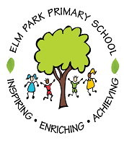
Connected Curriculum Theme Plan
Class: Beech and Maple Terms 1-2
What is London like?
BANG
Map skills day
WOW
Class museum

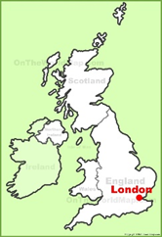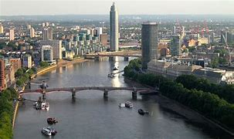
Achieve
Inspire

Enrich
At Elm Park, our learning will be driven by:
Community | Wellbeing | Creativity
In order to deepen our understanding of community, we will:  Understand about where we live within the world and the UK.  Look at images and videos of life in London and compare this to our local community in Winterbourne.  Share our learning with other members of the school. | We will learn about our wellbeing by:  Evaluating our work and celebrating our achievements together.  Observing the weather and seasons outside.  Learning to work together as part of a small group and a whole class. | In order to deepen our creativity, we will:  Make maps of London.  Create a news report to retell the events of the Great Fire of London.  Make sculptures using clay and card.
Areas of Learning |  | As writers we will:
As historians we will: |  | - Create a map of London with labels.  - Write a diary entry in role as a person who witnessed the Great Fire of London.  - Make a simple timeline of the history of London.
Investigate and interpret the past
Understand chronology
Build an overview of ‘The Great Fire of London’
Communicate historically
We will look at
- Describing historical events
- Ordering events on a timeline
- Pieces of evidence to ask and answer questions
- Describing significant people from the past.
As scientists we will |  | As mathematicians we will:
Work scientifically  Understand the Earth’s movement in space |  | - Learn to give and follow simple directions e.g. forward/backward and left/right.  - Draw simple maps and begin to explore using simple grid references.  - Sequence events in chronological order using language [for example, before and after, next, first, today, yesterday]  - Add dates to our timelines.
We will look at:
- Observing the apparent movement of the Sun during the day.
- Observing changes across the four seasons.
- Observing and describing weather associated with the seasons and how day length varies.
- Asking questions and using observations to answer them.

As Geographers we will:
Investigate places within the UK, specifically London  Communicate geographically, using technical vocabulary |  | Discrete learning:
- In RE we will consider the key question:
Y1: Who do Christians say made the world?
Y2: What is the good news Christians say Jesus brings?

- In PE we will practising: multi skills in Outdoor PE. In indoor PE will be looking at footwork and balancing.

- PSHE: The JIGSAW theme will be Being Me in My World.
We will look at:
- Using world maps, atlases and globes to identify the United Kingdom and its countries
- Using aerial images to recognise landmarks and basic physical features
- Using geographical vocabulary to refer to key physical and human features

