Elm Park Primary School
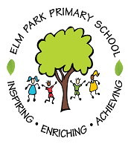
Connected Curriculum Theme Plan
Classes: Willow and Oak Terms 1-2
Why are rivers important?
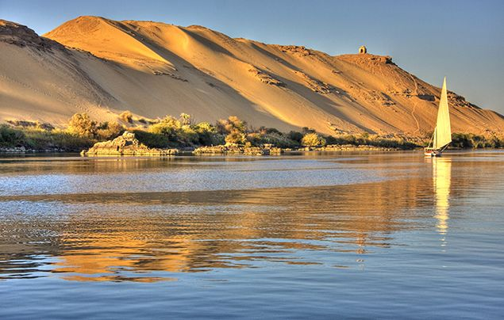
WOW
The children’s work will be exhibited in their class musuem.
BANG
The children will have the opportunity to take part in a River Workshops run by Bristol Avon Rivers Trust in their classroom.

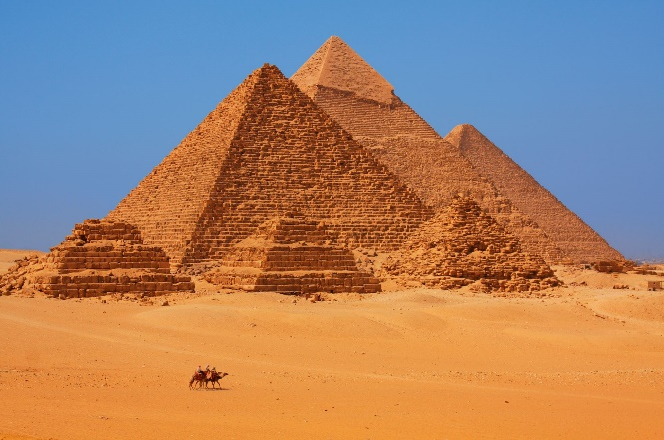

Achieve
Inspire
At Elm Park, our learning will be driven by:
Community | Wellbeing | Creativity
In order to deepen our understanding of community, we will:  Explore rivers in and around our community.  Dive back in history and look at how our local area sourced water.  Perform what we have learnt in music to our partner class. | We will learn about our wellbeing by:  Being outside, enjoying walks and being in nature.  Exploring cultural differences and understanding what life was like in the past.  Practising meditation by listening to river sounds. | In order to deepen our creativity, we will:  Make a model of a river with features.  Make a papyrus script with hieroglyphics  Create and perform a piece of music based around ostinatos.
Areas of Learning |  | As writers we will:
As historians we will: |  | - Write a script for a TV advert.  - Use hieroglyphics.  - Write a diary entry as a raindrop in a river.
- Investigate and interpret the past
- Understand chronology
- Build an overview of world history
- Communicate historically
We will look at
- Timelines of historical periods.
- Sources of evidence to deduce information about the past.
- A wide range of sources to seek out and analyse evidence in order to justify claims about the past.

As scientists we will |  | As mathematicians we will:
- Work scientifically  - Understand the structure of plants |  | - We will be using our ordering skills to order events and dates on a time line.  - Using our measuring skills in Science.
We will look at:
- Identify and describe the functions of different parts of flowering plants: roots, stem, leaves and flowers.
- Explore the requirements of plants for life and growth.
- Investigate the way in which water is transported within plants.
As Geographers we will:
- Identify the UK and wider world studying physical and human characteristics.  - Use maps to locate places. |  | Discrete learning:
- In RE we will consider the key questions:
Year 3 Term 1- What is it like for someone to follow God?
Year 4 Term 1: What kind of world did Jesus want?

- In PE we will: be practising our footwork and balancing skills.

- Our theme for PSHE will be: Being Me in my World
We will look at:
- A local river
- Land use of the river Nile
- Features of a river
- The water cycle

