Elm Park Primary School
Inspiring Learners, Enriching Lives, Achieving Together

Complaints Policy


Written by | Carol Bond
Updated by | C. Bond
Start Date | March 2022
Updated | March 2025
Review date | March 2028

Policies, Procedures or Practices: | Complaints | DATE: | 15.03.2022  March 2025
EIA CARRIED OUT BY: | C Bond | EIA APPROVED BY:

Groups that may be affected:
Are there concerns that the policy could have a different impact on any of the following groups? (please tick the relevant boxes) | Existing or potential adverse impact | Existing or potential for a positive impact
Age (young people, the elderly; issues surrounding protection and welfare, recruitment, training, pay, promotion)

Disability (physical and mental disability, learning difficulties; issues surrounding access to buildings, curriculum and communication)
Gender reassignment
Marriage and civil partnership

Pregnancy and maternity
Race

Religion and belief (practices of worship, religious or cultural observance, including non-belief)
Gender identity
Sexual orientation

Any adverse impacts are explored in a Full Impact Assessment.

Contents
Model complaints procedure 4
Who can make a complaint? 4
The difference between a concern and a complaint 4
Initial concerns 4
How to raise a concern or make a complaint 4
Anonymous complaints 5
Time scales 5
Complaints received outside of term time 5
Deviation from the Complaints Procedure 5
Scope of this Complaints Procedure 5
Resolving complaints 7
Withdrawal of a complaint 7
Dealing with complaints 7
Stage 1 8
Stage 2 8
Possible outcomes 10
The decision Letter 10
Next Steps 10
Appendix 1 - Complaint Form 11
Appendix 2 - Roles and Responsibilities 13
Complainant 13
Principles for investigation 13
Clerk to the Governing Board/Complaints Panel 14
Panel Chair 14
Panel Member 15
Appendix 3 - Complaints Flowchart 16
Appendix 4 - Summary Timeline 17

Complaints procedure

Who can make a complaint?
This complaints procedure is not limited to parents or carers of children that are registered at the
School. Any person, including members of the public, may make a complaint to Elm Park Primary School about any provision of facilities or services that we provide. Unless complaints are dealt with under separate statutory procedures (such as appeals relating to exclusions or admissions), we will use this complaints procedure.

The difference between a concern and a complaint
A concern may be defined as ‘an expression of worry or doubt over an issue considered to be important for which reassurances are sought’.
A complaint may be defined as ‘an expression of dissatisfaction however made, about actions taken or a lack of action’.

Initial concerns
It is in everyone’s interest that concerns and complaints are resolved at the earliest possible stage. Many issues can be resolved informally, without the need to use the formal stages of the complaints procedure. Elm Park Primary School takes concerns seriously and will make every effort to resolve the matter as quickly as possible.
If you have difficulty discussing a concern with a particular member of staff, we will consider your views. In these cases, the Headteacher, may refer you to another staff member. Similarly, if the member of staff directly involved feels unable to deal with a concern, the Headteacher may refer you to another staff member. The member of staff may be more senior but does not have to be. The ability to consider the concern objectively and impartially is more important.
We understand, however, that there are occasions when people would like to raise their concerns formally. In this case, Elm Park Primary will attempt to resolve the issue internally, through the stages outlined within this complaints procedure.

How to raise a concern or make a complaint
A concern or complaint can be made in person, in writing including email, or by telephone. They may also be made by a third party acting on behalf on a complainant, as long as they have appropriate consent to do so.
Concerns should be raised with either the class teacher or Headteacher. If the issue remains unresolved, the next step is to make a formal complaint.
Complainants should not approach individual Governors to raise concerns or complaints. They have no power to act on an individual basis and it may also prevent them from considering complaints at Stage 2 of the procedure.
- Complaints against school staff (except the Headteacher) should be made in the first instance to the Headteacher via the school office. Please mark them as Private and Confidential.
- Complaints that involve or are about the Headteacher should be addressed to the Chair of Governors, via the School office. Please mark them as Private and Confidential.
- Complaints about the Chair of Governors, any individual Governor or the whole Governing Board should be addressed to the Clerk to the Governing Body, via the School office. Please mark them as Private and Confidential.
For ease of use, a template complaint form is included at the end of this procedure. If you require help in completing the form, please contact the School office. You can also ask third party organisations like the Citizens Advice to help you.
In accordance with equality law, we will consider making reasonable adjustments, if required, to enable complainants to access and complete this complaints procedure. For instance, providing information in alternative formats, assisting complainants in raising a formal complaint or holding meetings in accessible locations.

Anonymous complaints
We will not normally investigate anonymous complaints. However, the Headteacher or Chair of Governors, if appropriate, will determine whether the complaint warrants an investigation. We may consider using this information to reflect on our processes if we feel this is warranted, but the information will not be shared.

Time scales
You must raise the complaint within three months of the incident or, where a series of associated incidents have occurred, within three months of the last of these incidents. We will consider complaints made outside of this time frame if exceptional circumstances apply.

Complaints received outside of term time
We will consider complaints made outside of term time to have been received on the first school day after the holiday period.

Deviation from the Complaints Procedure
There may be occasions when it is necessary or reasonable to deviate from this published procedure. If this is necessary then an explanation for doing so will be provided to all parties to the complaint.

Scope of this Complaints Procedure
This procedure covers all complaints about any provision of facilities or services by Elm Park Primary, other than complaints that are dealt with under other statutory procedures, including those listed overleaf.

 | Exceptions | Who to contact
•  •  • | Admissions to schools  Statutory assessments of  Special Educational Needs School re-organisation proposals | Concerns about admissions, statutory assessments of Special Educational Needs, or school re-organisation proposals should be raised with South Gloucestershire Children, Adults and Health Department.
• | Matters likely to require a Child Protection Investigation | Complaints about child protection matters are handled under our child protection and safeguarding policy and in accordance with relevant statutory guidance.  If you have serious concerns, you may wish to contact the local authority designated officer (LADO) who has local responsibility for safeguarding.
• | Exclusion of children from school* | Further information about raising concerns about exclusion can be found at: www.gov.uk/schooldiscipline-exclusions/exclusions.  *complaints about the application of the behaviour policy can be made through the school’s complaints procedure.
• | Whistleblowing | We have an internal whistleblowing procedure for all our employees, including temporary staff and contractors.  The Secretary of State for Education is the prescribed person for matters relating to education for whistleblowers in education who do not want to raise matters direct with their employer. Referrals can be made at: www.education.gov.uk/contactus.  Volunteer staff who have concerns about our school should complain through the school’s complaints procedure. You may also be able to complain direct to the LA or the Department for Education (see link above), depending on the substance of your complaint.
• | Staff grievances | Complaints from staff will be dealt with under the school’s internal grievance procedures.
• | Staff conduct | Complaints about staff will be dealt with under the  School’s internal disciplinary procedures, if appropriate. Complainants will not be informed of any disciplinary action taken against a staff member as a result of a complaint. However, the complainant will be notified that the matter is being addressed.
• | Complaints about services provided by other providers  who may use school premises  or facilities | Providers should have their own complaints procedure to deal with complaints about service. Please contact them direct.
• | National Curriculum - content | Please contact the Department for Education at:  www.education.gov.uk/contactus

If other bodies are investigating aspects of the complaint, for example the police, local authority (LA) safeguarding teams or Tribunals, this may impact on our ability to adhere to the timescales within this procedure or result in the procedure being suspended until those public bodies have completed their investigations.
If, at any stage of the complaint, it becomes apparent that the Complainant is seeking some sort of financial compensation then any investigation will be halted whilst advice is sought from the Local Authority Risk Management and Insurance Department.
If a complainant commences legal action in relation to their complaint, we will consider whether to suspend the complaints procedure in relation to their complaint until those legal proceedings have concluded.

Resolving complaints
At each stage in the procedure, Elm Park Primary wants to resolve the complaint. If appropriate, we will acknowledge that the complaint is upheld in whole or in part. In addition, we may offer one or more of the following:
- an explanation;
- an admission that the situation could have been handled differently or better;
- an assurance that we will try to ensure the event complained of will not recur;
- an explanation of the steps that have been or will be taken to help ensure that it will not happen again and an indication of the timescales within which any changes will be made; • an undertaking to review school policies in light of the complaint; • an apology.

Withdrawal of a complaint
If a complainant wants to withdraw their complaint, they will be asked to confirm this in writing.

Dealing with complaints
The following procedure will be used when initial attempts to resolve a concern are unsuccessful and the person raising the concern remains dissatisfied and wishes to take the matter further.
There are 2 stages in the procedure:
- Stage 1 – Complaint could be investigated by a) the Headteacher b) the Chair or Governors or c) an independent Governor³;
- Stage 2 – Complaint investigated by a Panel of Governors.
If the complaint is:
- jointly about the Chair and Vice Chair or
- the entire Governing Board or
- the majority of the Governing Board
then Stage 1 will be considered by an independent suitably skilled /Governor³. At the conclusion of their investigation, the independent Governor/investigator will provide a formal written response.
Stage 2 will be considered by an independent Panel³, the Local Authority or Diocese.

Stage 1
Formal complaints must be made to the Headteacher (unless they are about the Headteacher), via the School office. This may be done in person, in writing (preferably on the Complaint Form), or by telephone.
The Headteacher will record the date the complaint is received and will acknowledge receipt of the complaint in writing (either by letter or email) within 5 school days.
Within this response, the Headteacher will seek to clarify the nature of the complaint, ask what remains unresolved and what outcome the complainant would like to see. The Headteacher can consider whether a face to face meeting is the most appropriate way of doing this.
During the investigation, the Headteacher (or designated investigator) will:
- if necessary, interview those involved in the matter and/or those complained of, allowing them to be accompanied if they wish;
- keep a written record of any meetings/interviews in relation to their investigation.
At the conclusion of their investigation, the Headteacher will provide a formal written response to the complainant within 15 school days of the date of receipt of the complaint.
If the Headteacher is unable to meet this deadline, they will provide the complainant with an update and revised response date.
The response will detail any actions taken to investigate the complaint and provide a full explanation of the decision made and the reason(s) for it. Where appropriate, it will include details of actions Elm Park Primary will take to resolve the complaint.
The Headteacher will advise the complainant of how to escalate their complaint should they remain dissatisfied with the outcome of Stage 1.
Complaints about the Headteacher or member of the Governing Board must be made to the Clerk, via the School office.

Stage 2
If the complainant is dissatisfied with the outcome at Stage 1 and wishes to take the matter further, they can escalate the complaint to Stage 2 – a meeting with members of the Governing Board’s Complaints Panel, which will be formed of the first three, impartial, Governors available. This is the final stage of the complaints procedure.
The complaints Panel will consist of Governors with no prior involvement or knowledge of the complaint. Prior to the meeting, they will decide amongst themselves who will act as the Chair of the Complaints Panel. If there are fewer than three Governors from Elm Park Primary available, the Clerk will source additional, independent Governors³ in order to make up the required number. In exceptional circumstances, an entirely independent Panel of Governors³ may be convened to hear the complaint at Stage 2.
A request to escalate to Stage 2 must be made to the Clerk to Governors, via the School office, within 15 school days of receipt of the Stage 1 response.
The Clerk to Governors will record the date the complaint is received and acknowledge receipt of the complaint in writing (either by letter or email) within 5 school days.
Requests received outside of this time frame will only be considered if exceptional circumstances apply.
The Clerk will write to the complainant to inform them of the date of the Panel meeting. They will aim to convene a meeting within 20 school days of receipt of the Stage 2 request. If this is not possible, the Clerk will provide an anticipated date and keep the complainant informed.
The Panel will decide whether to deal with the complaint by inviting the parties to separate face to face meetings or through written representations, but in making their decision they will be sensitive to the complainant’s needs.
If the complainant rejects the offer of three proposed dates, without good reason, the Complaints
Panel Chair will decide when to hold the meeting. It will then proceed in the complainant’s absence on the basis of written submissions from both parties.
If the complainant is invited to attend a meeting, they may bring someone along to provide support. This can be a relative or friend. Generally, we do not encourage either party to bring legal representatives to the Panel meeting. However, there may be occasions when the complainant may wish to be supported by legal representation on the understanding that their role in this case is in a support role and not as legal representative.
For instance, if a school employee is called as a witness in a complaint meeting, they may wish to be supported by union and/or legal representation.
Note: Complaints about staff conduct will not generally be handled under this complaints procedure. Complainants will be advised that any staff conduct complaints will be considered under staff disciplinary procedures, if appropriate, but outcomes will not be shared with them.
Representatives from the media are not permitted to attend.
At least 10 school days before the meeting, the Clerk will:
- confirm and notify the complainant of the date, time and venue of the meeting, ensuring that, if the complainant is invited, the dates are convenient to all parties and that the venue and proceedings are accessible;
- request that copies of any further written material be submitted to the Clerk at least 5 school days before the meeting.
Any written material will be circulated to all parties at least 3 school days before the date of the meeting. The Panel will not normally accept, as evidence, recordings of conversations that were obtained covertly and without the informed consent of all parties being recorded.
The Panel will also not review any new complaints at this stage or consider inclusion of evidence unrelated to the initial complaint. New complaints must be dealt with from Stage 1 of the procedure.
The meeting will be held in private. Electronic recordings of meetings or conversations are not normally permitted unless a complainant’s own disability or special needs require it. Prior knowledge and consent of all parties attending must be sought before meetings or conversations take place. Consent will be recorded in any minutes taken.

Possible outcomes
The Panel will consider the complaint and all the evidence presented. The Panel can:
- uphold the complaint in whole or in part
- dismiss the complaint in whole or in part
- Deem the result inconclusive – it is not possible to determine whether the complaint or an element of the complaint is upheld. This is where there is not enough evidence either way e.g. where there is one word against another.
If the complaint is upheld in whole or in part, the Panel will:
- decide on the appropriate action to be taken to resolve the complaint
- where appropriate, recommend changes to the School’s systems or procedures to prevent similar issues in the future.
If the complaint is not upheld or is inconclusive the Panel will, where appropriate, record and make recommendations in respect of any lessons learnt or opportunities to improve.

The decision Letter
The Chair of the Panel will provide the complainant and Elm Park Primary with a full explanation of their decision and the reason(s) for it, in writing, within 5 school days.
The letter to the complainant will include details of how to contact the Department for Education if they are dissatisfied with the way their complaint has been handled by Elm Park Primary.

Next Steps
If the complainant believes the School did not handle their complaint in accordance with the published complaints procedure or they acted unlawfully or unreasonably in the exercise of their duties under education law, they can contact the Department for Education after they have completed Stage 2.
The Department for Education will not normally reinvestigate the substance of complaints or overturn any decisions made by Elm Park Primary. They will consider whether Elm Park Primary has adhered to education legislation and any statutory policies connected with the complaint.
The complainant can refer their complaint to the Department for Education online at: www.education.gov.uk/contactus, by telephone on: 0370 000 2288 or by writing to:
Department for Education
Piccadilly Gate
Store Street Manchester M1 2WD.

Appendix 1 - Complaint Form
Please complete and return to the School Office, who will acknowledge receipt and explain what action will be taken.
Your name:
Pupil’s name (if relevant):

Your relationship to the pupil (if relevant):

Address:
Postcode:
Day time telephone number:
Evening telephone number:
Please give details of your complaint, including whether you have spoken to anybody at the School about it.

What actions do you feel might resolve the problem at this stage?

Are you attaching any paperwork? If so, please give details.

Signature:

Date:
Official use
Date acknowledgement sent:

By who:

Complaint referred to:

Date:

Appendix 2 - Roles and Responsibilities

Complainant
The complainant will receive a more effective response to the complaint if they:
- explain the complaint in full as early as possible
- co-operate with the School in seeking a solution to the complaint
- respond promptly to requests for information or meetings or in agreeing the details of the complaint
- ask for assistance as needed
- treat all those involved in the complaint with respect
- refrain from publicising the details of their complaint on social media and respect confidentiality.

Principles for investigation
When investigating a complaint, the investigator(s) will try to clarify:
- What has happened;
- Who was involved;
- What the complainant feels would put things right.
The investigator(s) role is to establish the facts relevant to the complaint by:
- providing a comprehensive, open, transparent and fair consideration of the complaint through:
  - where required, sensitive and thorough interviewing of the complainant to establish what has happened and who has been involved;
  - when necessary, interviewing staff and children/young people and other people relevant to the complaint;
  - consideration of records and other relevant information; o analysing information.
The investigator(s) should:
- conduct interviews with an open mind and be prepared to persist in the questioning;
- keep notes of interviews or arrange for an independent note taker to record minutes of the meeting;
- ensure that any papers produced during the investigation are kept securely pending any appeal;
- be mindful of the timescales to respond;
- prepare a comprehensive report that sets out the facts, identifies solutions and recommends courses of action to resolve problems.

Complaints Co-ordinator / Clerk
The complaints co-ordinator should:
- ensure that the complainant is fully updated at each stage of the procedure;
- liaise with staff members, Headteacher, Chair of Governors, Panel members and LAs (if appropriate) to ensure the smooth running of the complaints procedure; • be aware of issues regarding:
  - sharing third party information;
  - additional support. This may be needed by complainants when making a complaint including interpretation support or where the complainant is a child or young person; • keep records.

Clerk to the Governing Board/Complaints Panel
The Clerk is the contact point for the complainant and the Panel and should:
- ensure that all people involved in the complaint procedure are aware of their legal rights and duties, including any under legislation relating to school complaints, education law, the Equality Act 2010, the Freedom of Information Act 2000, the Data Protection Act (DPA) 2018 and the General Data Protection Regulations (GDPR);
- set the date, time and venue of the meeting, ensuring that the dates are convenient to all parties (if they are invited to attend) and that the venue and proceedings are accessible;
- collate any written material relevant to the complaint (for example; stage 1 paperwork, school and complainant submissions) and send it to the parties in advance of the meeting within an agreed timescale;
- record the proceedings;
- circulate the minutes of the meeting;
- notify all parties of the Panel’s decision.

Panel Chair
The Panel’s Chair, who is nominated in advance of the complaint meeting, should ensure that:
- both parties are asked (via the Clerk) to provide any additional information relating to the complaint by a specified date in advance of the meeting;
- the meeting is conducted in an informal manner, is not adversarial, and that, if all parties are invited to attend, everyone is treated with respect and courtesy;
- complainants who may not be used to speaking at such a meeting are put at ease. This is particularly important if the complainant is a child/young person;
- the remit of the Panel is explained to the complainant;
- written material is seen by everyone in attendance, provided it does not breach confidentiality or any individual’s rights to privacy under the DPA 2018 or GDPR;
- both the complainant and the School are given the opportunity to make their case separately
to the Panel and the Panel may seek clarity, either through written submissions ahead of the meeting or verbally in the meeting itself;
- the issues are addressed;
- key findings of fact are made;
- the Panel is open-minded and acts independently;
- no member of the Panel has an external interest in the outcome of the proceedings or any involvement in an earlier stage of the procedure;
- the meeting is minuted;
- they liaise with the Clerk (and complaints co-ordinator, if the school has one).

Panel Member
Panel members should be aware that:
- the meeting must be independent and impartial, and should be seen to be so;
No Governor may sit on the Panel if they have had a prior involvement in the complaint or in the circumstances surrounding it;
- the aim of the meeting should be to resolve the complaint and achieve reconciliation between the School and the complainant;
We recognise that the complainant might not be satisfied with the outcome if the complaint does not find in their favour. It may only be possible to establish the facts and make recommendations;
- many complainants will feel nervous and inhibited in a formal setting;
Parents/carers often feel emotional when discussing an issue that affects their child;
- extra care needs to be taken when the complainant is a child/young person and present during all or part of the meeting:
  - Careful consideration of the atmosphere and proceedings should ensure that the child/young person does not feel intimidated.
  - The Panel should respect the views of the child/young person and give them equal consideration to those of adults.
  - If the child/young person is the complainant, the Panel should ask in advance if any support is needed to help them present their complaint. Where the child/young person’s parent is the complainant, the Panel should give the parent the opportunity to say which parts of the meeting, if any, the child/young person needs to attend.
  - However, the parent should be advised that agreement might not always be possible if the parent wishes the child/young person to attend a part of the meeting that the Panel considers is not in the child/young person’s best interests.
- the welfare of the child/young person is paramount.

Appendix 3 - Complaints Flowchart

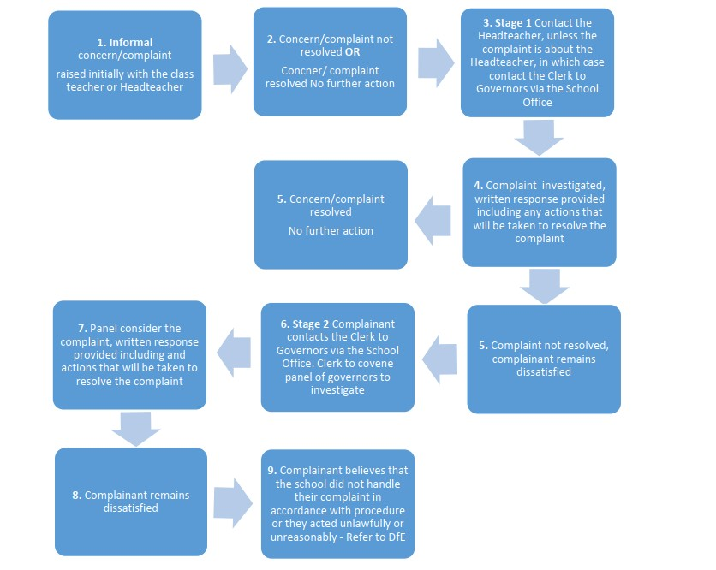

Appendix 4 - Summary Timeline
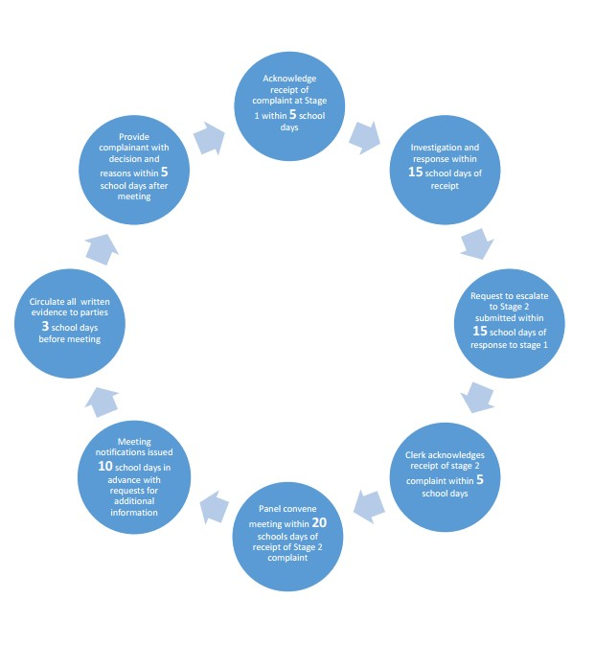

There may be occasions when it is necessary or reasonable to deviate from this published procedure or timelines. If this is necessary then an explanation for doing so will be provided to all parties to the complaint.

The Headteacher may delegate the investigation to another member of the school’s senior leadership team, but not the decision to be taken.
The Chair of Governors would normally investigate any complaint about the Headteacher however, there may be occasions when the Chair is not untainted by the circumstances. In these instances the Stage 1 investigation and decision will be undertaken by a suitably skilled independent governor. ³ This may be a governor(s) from another governing board.
Should the need arise the Clerk to the Governing Board may be replaced with an independent Complaints Clerk.

