
Dates for your diary
20.01.26 – Reading workshop for parents at 9am
30.01.26 – INSET Day
06.02.26 – PTFA Pamper Evening
09.02.26 – Children’s mental health week
13.02.26 – PTFA Valentines disco
13.02.26 – End of Term 3
Happy New Year to all our families! We hope you had a restful and enjoyable break and would like to thank you for your continued support as we begin an exciting new term together.
Inspiring Learners
We have started the term with a real bang by launching our new Connected Curriculum topics. Our Bang Day last Thursday was a fantastic success, with children taking part in immersive Virtual Reality workshops. The sessions sparked curiosity, excitement and lots of thoughtful discussion, giving the children a memorable and inspiring start to their learning.
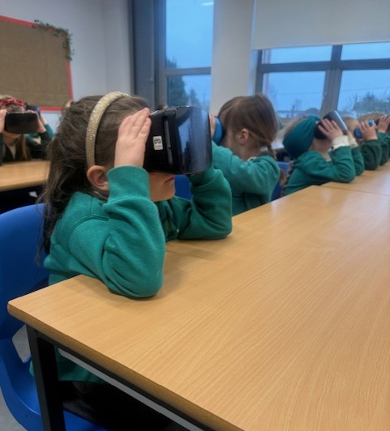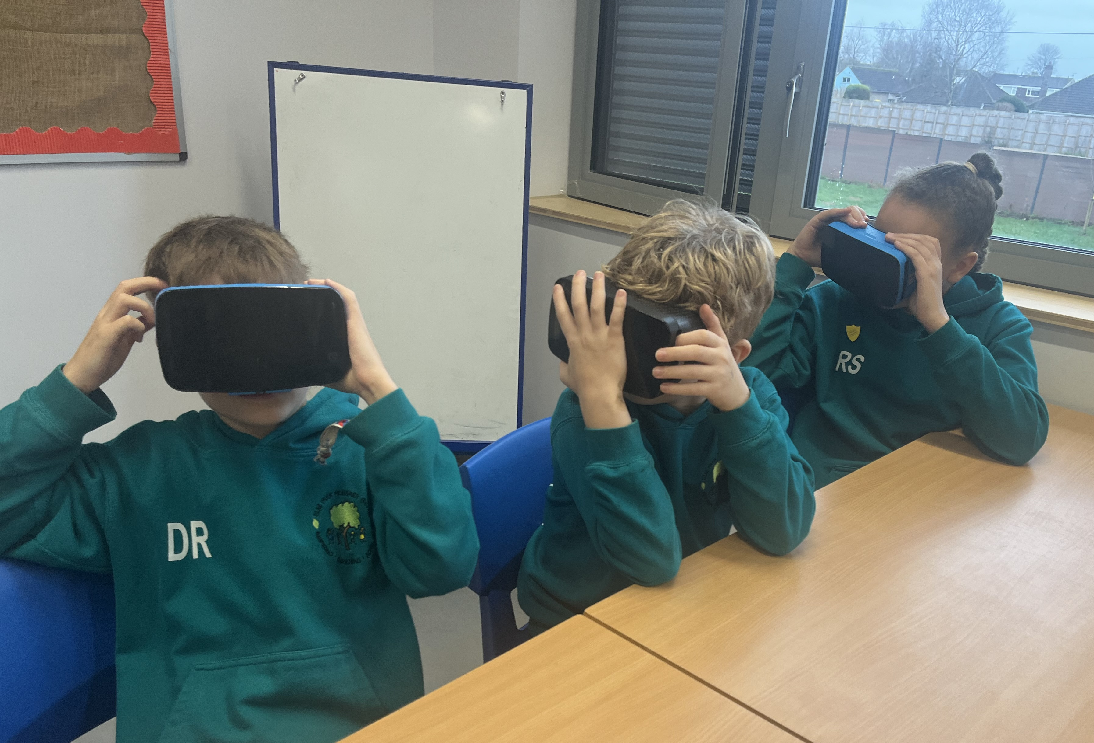

Enriching Lives
Our after-school clubs have also started again for the term and are already proving very popular with the children. We are pleased to be offering a range of activities including Glow in the Dark Sports, Lego Club, Calm Colouring and Science Club. These clubs provide a great opportunity for children to explore new interests, develop skills and enjoy spending time with friends.
It was wonderful to welcome so many parents into school for the Beech Class parent lunch. The children were delighted to share their lunchtime with you, and it was lovely to see such a strong sense of community and partnership between home and school.

Achieving Together
Since the beginning of term, you have been sent a number of documents designed to help you support your children’s learning. You will have received a class newsletter which gives you information about the topics being covered in English, Maths and the Connected Curriculum. You will also have had a knowledge organiser that gives the key knowledge that the children will be learning in the Connected Curriculum. This week, you will have received a maths newsletter, giving you ways to support your children to learn their Key Instant Recall Facts (KIRFs). Please take time to read these documents and talk to your children about their learning.
We would like to warmly invite parents and carers to our Reading Workshop at 9:00am on Tuesday morning. This session will share practical ideas and strategies to help you support your child with reading at home, and we hope you will be able to join us.

Reminder: Please can you make sure that you are not using your mobile while on school property. This includes the school playground. Many thanks.
Important notice

Thank you to the Year 1 parents who came for lunch yesterday and to Deb and Lisa in the kitchen for our delicious food.

Thank you to all the parents who are regularly supporting their children with homework and reading. It makes such a difference!

The PTFA plays a vital role in raising funds that directly benefit the children, and we are always grateful for the support of our families. There are some exciting events coming up, including a Pamper Evening and the Valentine’s Disco at the end of term. We hope as many parents and carers as possible will be able to support these events and help make them a success. Please look out for more information about these events soon.

Reminders
• Please remember that jewellery should not be worn to school, with the exception of one pair of small stud earrings. Necklaces, bracelets and other items of jewellery should be left at home.
• Please ensure that your child brings a coat to school every day, as we spend time outdoors in all weathers.

Thank you for your continued support.

Wishing you all a very enjoyable weekend.
Sarah Lugg
Deputy Head Teacher

